**UGANDA MATYRS UNIVERSITY.**

**MOBILE COMPUTING AND NETWORKS.**

**BOOK LIFE MOBILE APPLICATION DOCUMENTATION.**

Lec: Mr. Kasozi Brian.

Contributors.

MUJUZI DENNIS HARRISON 2021-B071-22445

SEBICU WILLIAM 2022-B072-21258

**Introduction.**

Booklife mobile application is an application that provides books to the reader at anytime from anywhere. The application is developed with a friendly and inclusive User interface with features like screen readers, user authentication, download option intended t

**Purpose of the Application.**

Providing a variety of book genres in a mobile application.

**Objectives.**

Providing a convenient platform for customers to browse and purchase books.

Enhancing customer experiences through personalized recommendations and user-friendly interfaces.

Increasing accessibility to a wider range of books.

**System Requirements.**

IOS version 11.1.1 and above.

Android version 5.0 and above.

A minimum of 2GB RAM.

At least 1GB of storage space.

**Key features.**

Advanced Search Options.

Efficient search functionality with filters and sorting options enables users to find specific books based on genres, authors, ratings.

Personalized Recommendations.

Using user preferences, the application can suggest relevant books to individual users, creating a personalized browsing experience.

Intuitive User Interface.

A clean and easy-to-navigate interface helps users find books quickly and efficiently.

User Reviews and Ratings.

Including user-generated reviews and ratings for books helps users make informed decisions when selecting books to purchase.

Wishlist and Saved Items.

Allowing users to create wishlist or save books for later enables them to track and revisit books they are interested in.

Buy/download/Save.

An option that enables a user to download or save a book in the application but not in the device files. The purchased book can be availed offline inside the application.

Offline Access.

Allowing users to download purchased books for offline reading ensures they can enjoy their books even without internet connectivity. The application does not save books to the devices storages but saves the downloaded book in the app its self to avoid sharing.

Seamless Checkout Process.

A simplified and secure checkout process with multiple payment options provides a hassle-free purchasing experience.

Notifications and Updates;

The application sends timely notifications about new book releases, discounts, and order updates keeps users informed and engaged.

Customer Support;

Offering a seamless customer support such as FAQs, Comment section or live chat helps users resolve any issues or queries they may have.

Book Tracking and Bookshelf Organization;

Allowing users to create a digital bookshelf to track their collection, mark books as read, and organize them based on categories or genres.

Screen readers;

This allows us to archive inclusivity at an extent in our application. Screen readers help the user to read content on the screen in the application. This may be of a greater use especially to the blind or disabled.

Multilingual Support;

Providing the option to browse and purchase books in different languages to cater to a diverse user base.

Integration with E-book Readers;

Offering integration with popular e-book readers, allowing users to sync their purchased books across devices for seamless reading.

Social Reading Features;

Enabling users to highlight and annotate text, share favourite quotes, and see what others are reading or recommending.

**Methodology.**

This explains the methods and processes that were used to archive the stated objectives. The methodology also describes the research design, case study, and phases involved in the development of the platform.

**Technology and tools used.**

We used the following tools to develop the platform.

1.Android Studio

We used Android studio an Integrated Development Environment for developing Mobile applications.

2.A computer with windows operating system.

3.Programming language.

We used Java as the programming language to enable logical operations such as logging into the application.

4.We used Figma to come up with the prototype designs of the application.

**Landing page.**

This is the first page that appears on opening the application. It directs the user to Login if they already have accounts or signup to create an account. It also consists of a call to action directing the user to access over 30+ million books in various languages across the world at their fingertips.

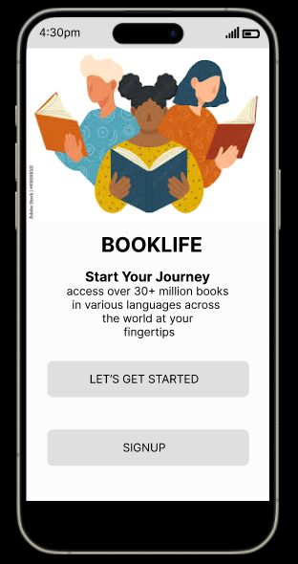

**Login page.**

This provides a user with a username and password inputs where the user is supposed to enter valid credentials to allow access into the application for security purposes.

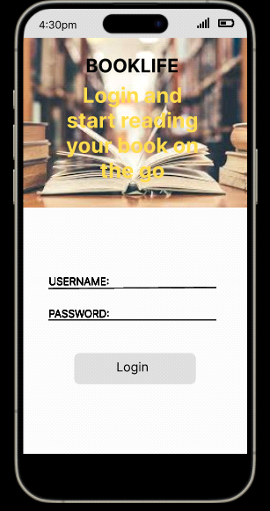

**Home page.**

This is the page that appears on the screen on logging in. It provides the user with a search button filtered with tittles and authors of the books.

A notification button that provides the user timely messages on trending books and new releases on market.

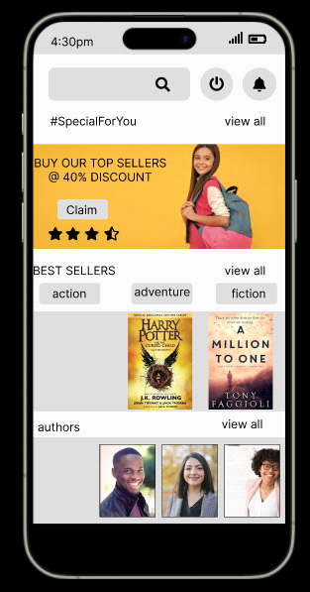

**Product Description.**

This is the page that appears on clicking on a book or product providing a summary description of the book.

An add to cart option is provided to allow customers download or purchase the book.

A save for offline option is also provided to allow users access and read their books offline.

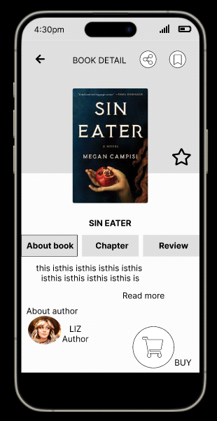

**Implementation details.**

The platform was implemented on an android device where the application was installed and tested from.

**Testing procedures.**

The testing of the platform was done through exposing the platform to a user in line with books and novels and the application was executed with an intent of finding errors and to confirm that functional and user requirements were met.

The application was tested module per module separately and then after we conducted an overall test with all modules.

**Conclusion.**

In conclusion, Booklife mobile application is relatively smart innovation that can have a positive impact to most of the readers that enjoy novels, stories as well as academic texts. The inclusiveness and uniqueness of the features of this application such as Screen readers, Available offline, a friendly user interface, allowing users to access books and read them on their phones at a go.